**Level 1: Problem Definition**

*Look and Feel of project:*

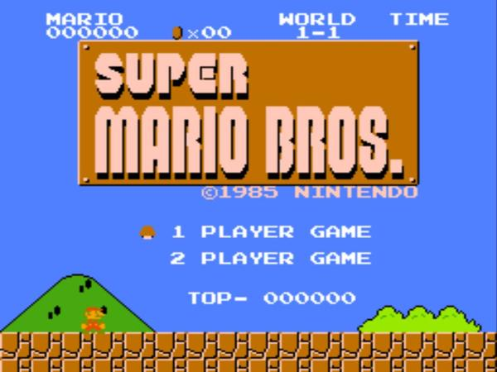 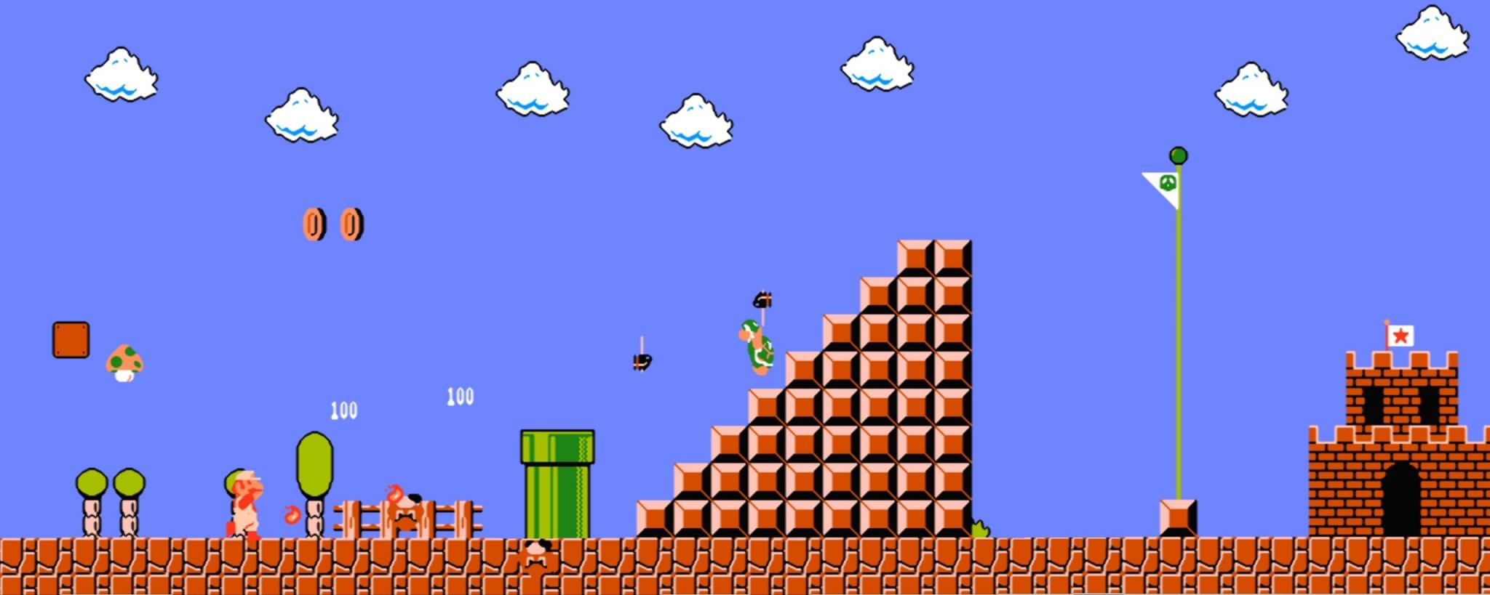

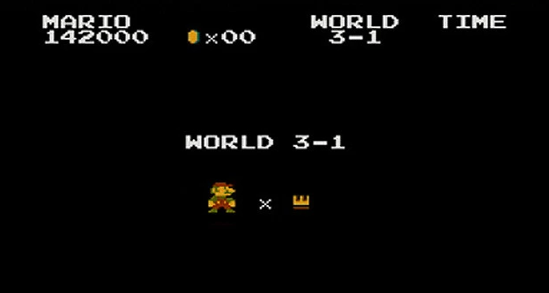

We’re planning on having similar style states like the Super Mario Bros game. We will have a title screen where you select the game mode and the score. We will have the actual game state where you play the game and a split screen where it shows your lives and the world.

*Operation and Key objectives:*

* Gameplay mechanics inspired of side scrollers such as Super mario, Rayman and Sonic the Hedgehog, and Megaman.
* Cartoon based design

*Tools and Java Packages:*

***Swing:***

*import javax.swing.JFrame; (To set the game screen/window)*

***Java Graphics:***

*Things needed to be learned:*

* Java Swing
* LibGDX Game Development
* Game programming concepts, like the states, game loop, movements, etc
* Sprite Sheets / Pixel art

*Nice to see features:*

* Graphical settings to give users a different/preferred perspective
* Clean UI that can be interfaced with a mouse
* Multiple Levels + Level select
* Pipe system to traverse through areas
* Game Save Options
* Cheat Codes and secrets for speed runners

**Player Details:**

* Mixtape as powerup
* Shoots fire mixtape as power
* Doritos as coins
* Grow (Health) - Mexican Food
* 1 up - Coin / Penny

*Must have function features:*

***Keyboard Controls:***

*Z = Fire / Speed*

*X = Jump*

*Arrow Left = Go Left*

*Arrow Right = Go Right*

*Arrow Down = Crouch / Go inside Pump(Downwards)*

*T = Take ScreenShot*

*I = Info*

*K= key changer*

***Or***

***Mouse Controls (On screen Buttons)***

* *Jump button*
* *Arrow Left Button = Go Left*
* *Arrow Right Button = Go Right*
* *Arrow Down Button = Crouch / Go inside Pump (Downwards)*
* *Fire / Speed Button*

***In game features:***

* Final Boss Fights
* In game secrets/collectibles
* Platforming (jumping) on structures
* Special/Secret Worlds (Completion Reward)

***Cheat code so that the main character Rahul does not become Cool.***

Summarize and explain the "big idea" of your project.

A 2D side scroller that portrays a simple plot to achieve quality in gameplay variation and level design (Similar to doom).

List some questions / unknowns that you have about the "user perspective" of your project?

* **What kinds of side scrollers are you into Sonic, Mario, Rayman, or Other?**
* **What Controls would you prefer, Mouse or Keyboard Based?**
* **Give us some suggestions on whether the graphics of the game is well perform or do we need to add something better to make the game more stand out?**
* **Give us feedback on any bugs or glitches that may happen inside the game?**
* **What improvements do you think we need to add to make the game more realistic?**

*To get the feedback flowing in control, the grade 11s will post their response on a shared Google Docs.*